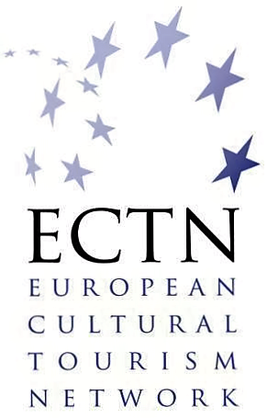

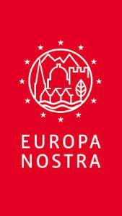
Awards
Awards

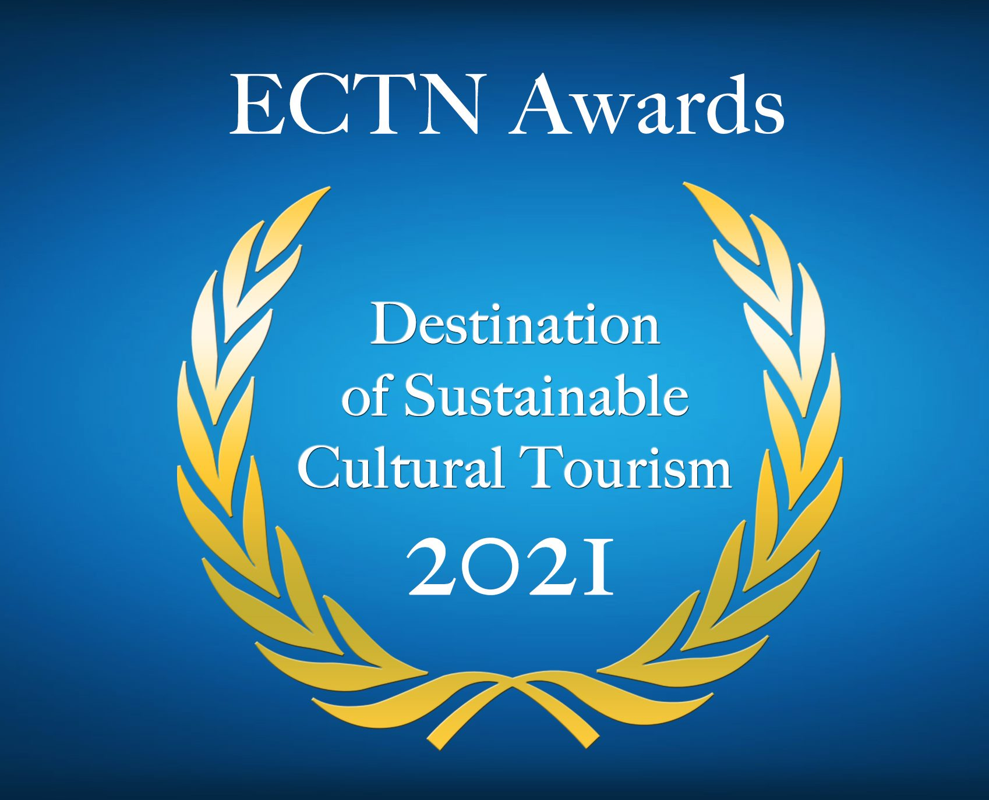

Regenerating European Tourism
through Culture, Heritage and Creativity

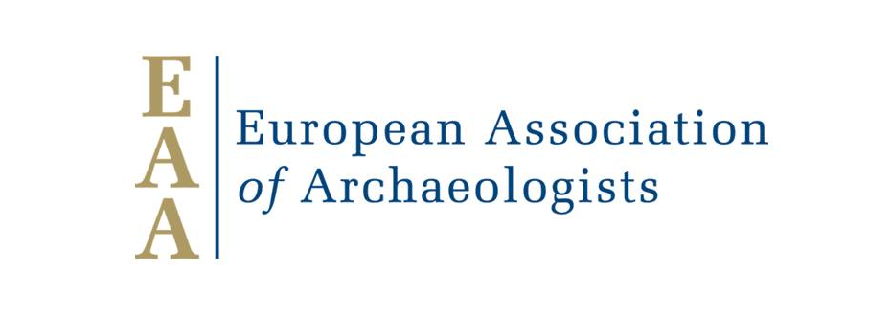
in partnership with:
Supported by:

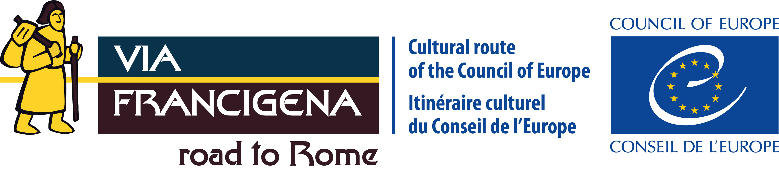
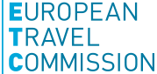

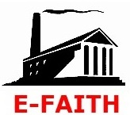

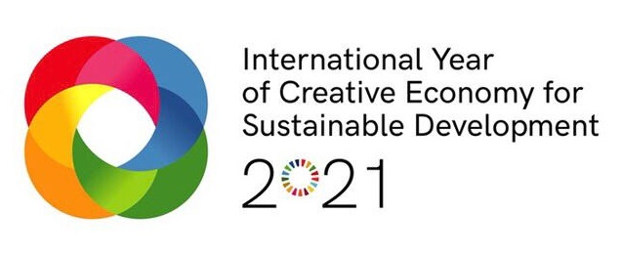
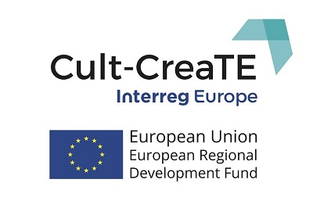
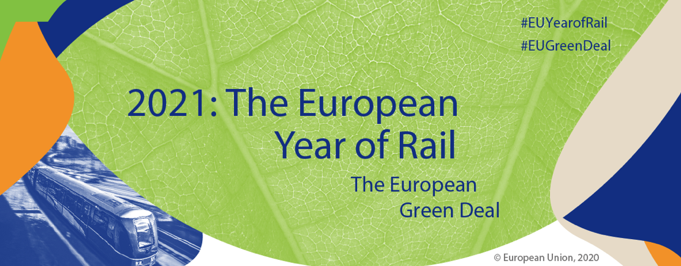
and in the framework of:

About the Awards

Cultural tourism is the fastest growing sector of European tourism and can contribute both to the sustainability and competitiveness of tourism in the European Union and beyond, as well as to the sustainable future of cultural assets, heritage sites and local communities.

Cultural Tourism products and services are important factors in sustainable development, contributing to the protection and promotion of cultural heritage, the extension of the tourism period, as well as increasing culture and heritage awareness among tourists and host communities, regional GDP and its multiplier effects.

These Awards enhance the visibility of European cultural tourism destinations, create a platform for sharing experience and knowledge and promotes networking between destinations. The Awards Contest is open to tourist destinations across Europe, to showcase their results and outputs in sustainable cultural tourism under several selected categories each year.

The Awards have been organised since 2014 by ECTN around annual themes, for the benefit of destinations, communities, associations, businesses, citizens and visitors.

The 2021 edition of the Awards for ‘Destination of Sustainable Cultural Tourism’ is organised by ECTN in partnership with Europa Nostra, the European Travel Commission and NECSTouR, supported by the Creative Tourism Network (CTN) and ‘Via Francigena' Cultural Route of the Council of Europe. It follows on from the 2018 edition of the Awards which was held as a contribution to the ‘European Year of Cultural Heritage’ (EYCH2018) and the 2019 and 2020 editions, by a similar partnership that aims to contribute towards the legacy of EYCH2018 through relevant EU initiatives.

Call for Entries

The 2021 overall theme is: ‘Regenerating European tourism through Culture, Heritage and Creativity’.

The Awards will be given for achievements by cultural tourist destinations which have produced significant results related to enhancing visitor experience while respecting traditions and involving local communities.

The 2021 Awards address the following heritage-related aspects of sustainable cultural tourism:

- Archaeological Sites and Museums as Cultural Tourism Attractions, supported by EAA – the European Association of Archaeologists
- Walking Tourism and Slow Travel – Synergies with Cultural Tourism, supported by Via Francigena Cultural Route of the Council of Europe
- Digitalisation in Sustainable Cultural Tourism, towards Smart Destinations
- Transnational Thematic Tourism Products, including European Cultural Routes
- Cultural and Creative Industries (CCIs) contribution to Cultural and Creative Tourism development, in the framework of the ‘International Year of Creative Economy for Sustainable Development 2021’ and Interreg Europe Cult-CreaTE project, supported by ‘Creative Tourism Network’
- Railway Heritage Assets for Cultural Tourism, in the framework of the ‘European Year of Rail 2021’, supported by FEDECRAIL – the European Federation of Museum and Tourist Railways and E-FAITH – the European Federation of Associations of Industrial and Technical Heritage.

The applicants must address one of the above themes and present projects/initiatives that have been completed during the past 3 years. Award winners will be recognised as examples of excellence inspiring other tourist destinations and stimulating further development of sustainable cultural tourism initiatives.

Award winners will be announced at the Awards Ceremony to be held during the 14th International Conference for Cultural Tourism on the theme of ‘Regenerating European tourism through Culture, Heritage and Creativity’, organised by ETCN on 20-23 October 2021 in Athens, Greece.

The selected finalists will be invited to the ECTN Conference 2021 and to the Awards Ceremony. The organiser and partners will not reimburse any costs for attending the Awards Ceremony, but the conference fee will be waived for up to two persons per finalist.

Who can apply?

The Joint Awards are open to all tourist destinations across Europe, national, regional and local authorities, tourism boards and associations, destination management organisations, museums, interpretation centres, cultural routes, festivals and cultural NGOs.

Application form, Declaration & deadline

The Application form and the required Declaration can be downloaded in Word format from website:
www.culturaltourism-network.eu/award-2021.html
Detailed instructions on how to fill in the application form are provided in the application form itself.

Please fill in all sections of the application form in English (applications in other languages will not be considered). Please sign the Declaration, scan and/or add a digital signature and send both the Application form and the Declaration together by e-mail to: awards@culturaltourism-net.eu .

No paper version of the application is needed – electronic submission only!

Application forms without the accompanying signed Declaration or with any incomplete fields will not be eligible.

Applications must be submitted by 1 June 2021 – 17:00 CET (Central European Time) at the latest.

By submitting the application, applicants authorise the publishing of their data on the organiser and partners’ websites:
www.culturaltourism-network.eu
www.europanostra.org
www.etc-corporate.org
www.necstour.eu
www.creativetourismnetwork.org
www.viefrancigene.org

Material submitted may be published by the organisers, with due acknowledgement to the applicant.

Awards Jury

The Awards Jury will be composed of experts from several European countries, appointed by ECTN, Europa Nostra, the European Travel Commission, NECSTouR, CTN, Via Francigena Cultural Route.

The Jury’s decision shall be final. The Jury will not accept requests for additional information or justification of their decision once the awardees have been selected.

Awards Criteria

The Awards Jury will assess the quality of applications according to the following criteria:

Relevance to the selected category and content quality
- Evidence of success (numbers of visitors, visitor satisfaction, publicity)
- Tourism Sustainability – Sustainable Development of Tourism (Economic, Social, Environmental)
- Ability to attract visitors from outside Europe and to lesser known destinations
- Innovative character
- Involvement of the local community
- Contribution to EU Green Deal and Climate Action (SDG 13)
- Inclusive Tourism aspects (facilitating family holidays, social tourism)
- Mitigating the impacts of the pandemic crisis, for resilience and recovery (only for projects finalised in 2020 and 2021).
Concluding Remarks

This is a non-profit initiative. Therefore, the Awards do not consist of any type of monetary prize and does not aim to give any type of economic advantage to the applicants and winners. No financial or contractual obligations will arise neither for ECTN, nor for the partner organisations (Europa Nostra, the European Travel Commission and NECSTouR), nor the supporting organisations (CTN and EAVF).

The Awards organiser, partners and supporters or their members and employees or contractors shall not be responsible nor liable in negligence or otherwise howsoever in respect of any inaccuracy or omission in the Awards procedure. They shall not be liable for any direct or indirect or consequential loss or damage caused by or arising from any information or inaccuracy or omission herein. They also shall not be liable for any use of the information concerning the Awards.

WE LOOK FORWARD TO RECEIVING YOUR APPLICATION!

#culturaldestination2021 #europeforculture

@ectn_eu

@europanostra

@ETC_Corporate

@NECSTouR

@CreativTourism

@AEVieFrancigene

in partnership with:
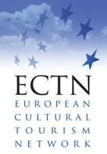
supported by:

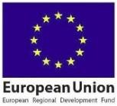
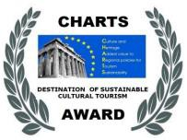

The ‘Destination of Sustainable Cultural Tourism Awards have been initiated by CHARTS project, co-financed by the European Regional Development Fund and made possible by the EU INTERREG IVC programme in 2014, continued with support by Interreg Europe projects CHRISTA (2016-2020),
Cult-RInG (2017-2021) and Cult-CreaTE (2018-2022)
www.interregeurope.eu/christa www.interregeurope.eu/cult-ring www.interregeurope.eu/cult-create
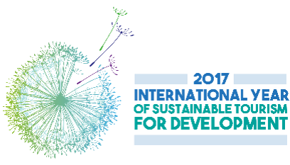
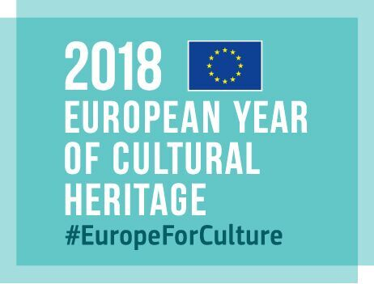

The 2018 Awards have been as a contribution to: 2017 Awards in the frame of:

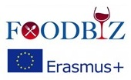
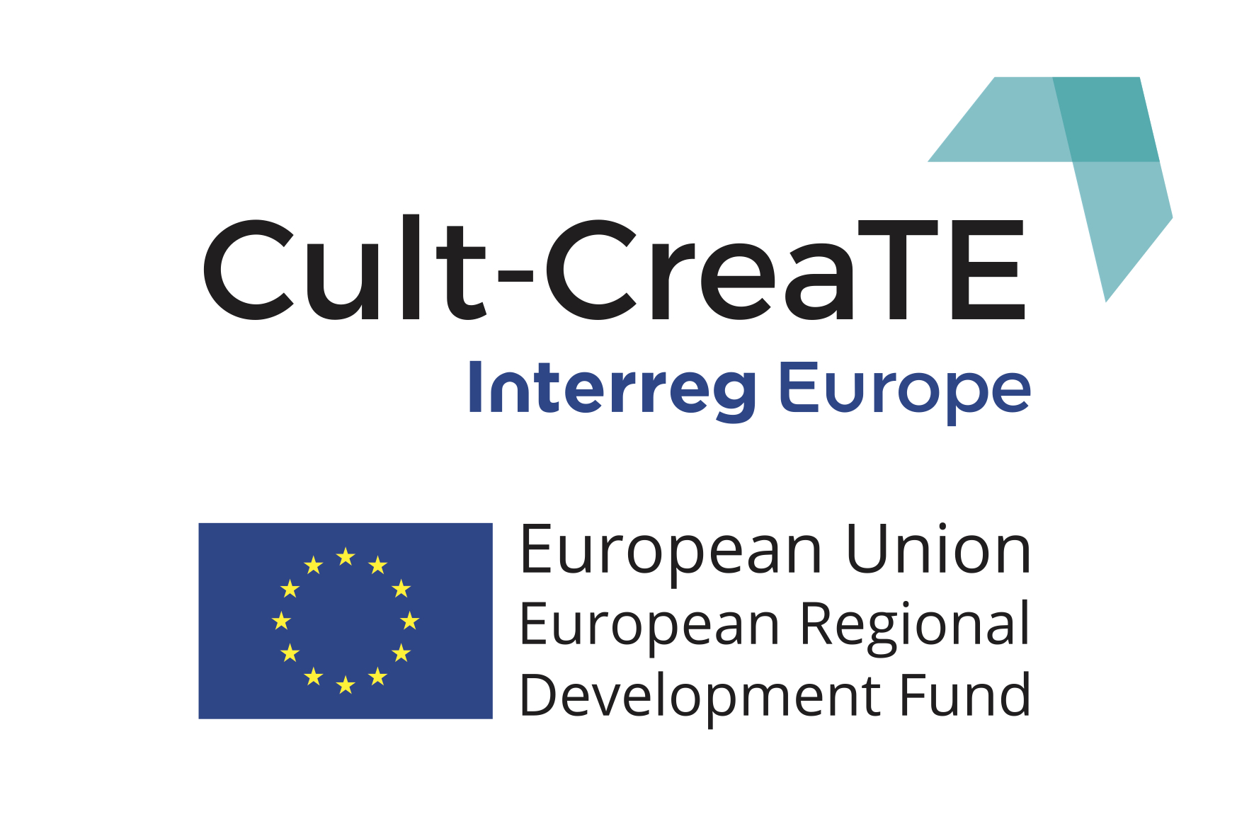
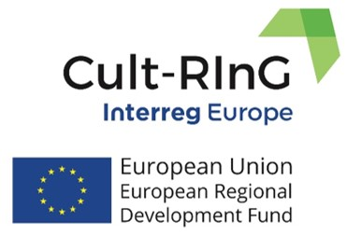
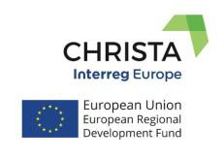
2019 Awards in the framework of EU co-funded projects:

2021 Awards in the framework of: and

