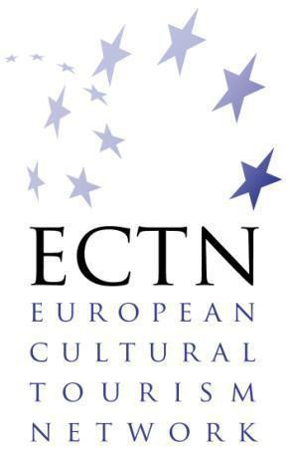
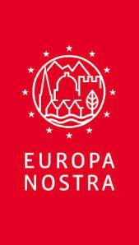
Awards

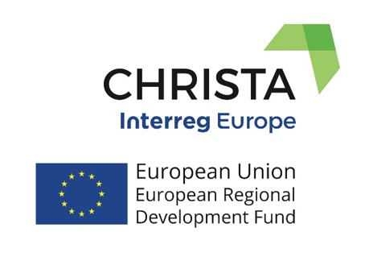
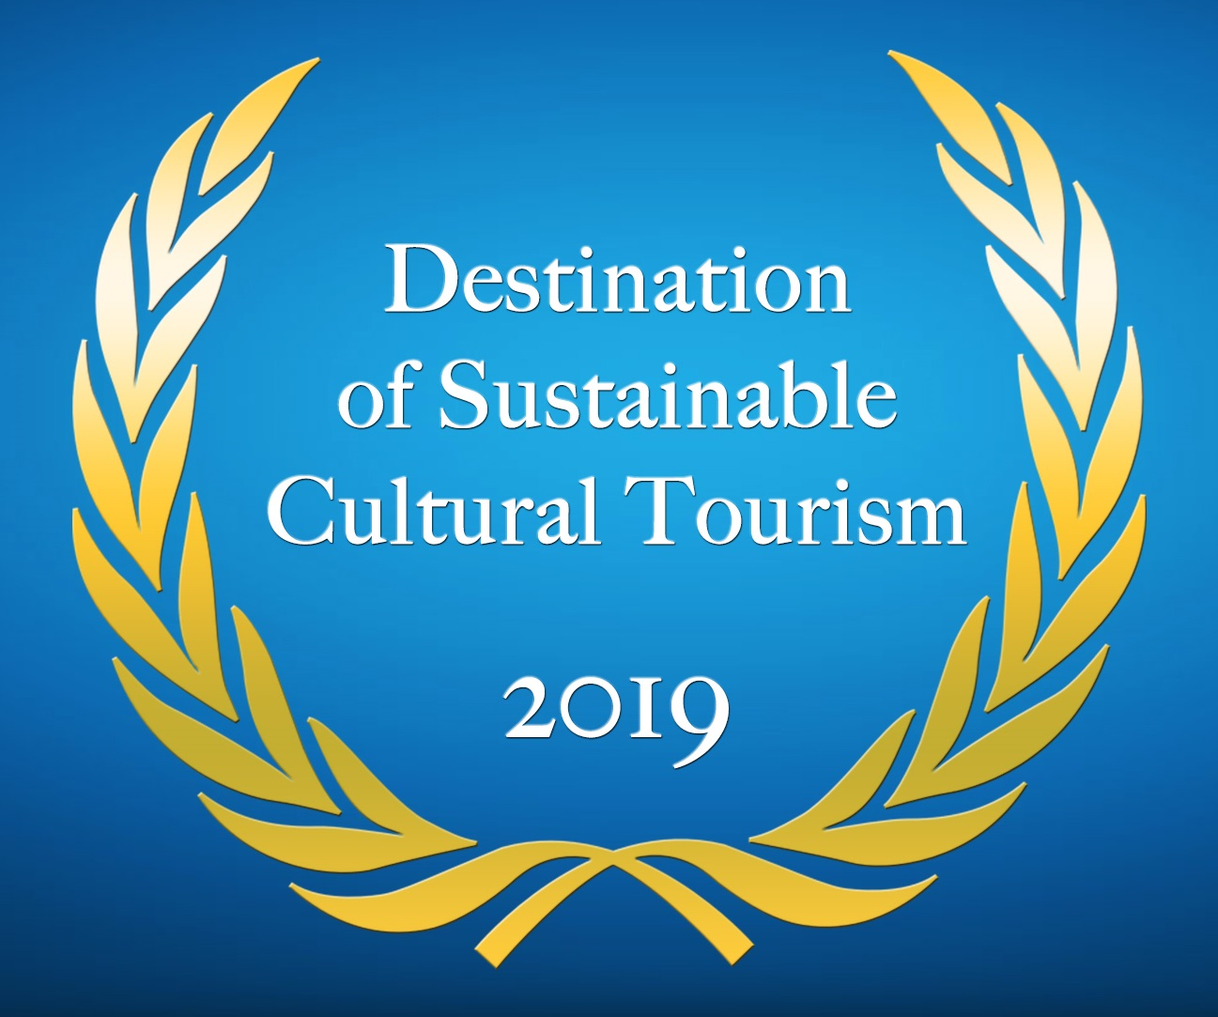
Awards

Culture and Heritage for Responsible, Innovative and Sustainable Tourism Actions

in partnership with:
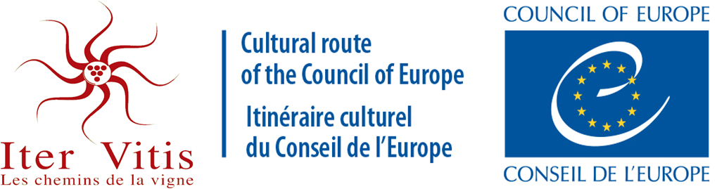
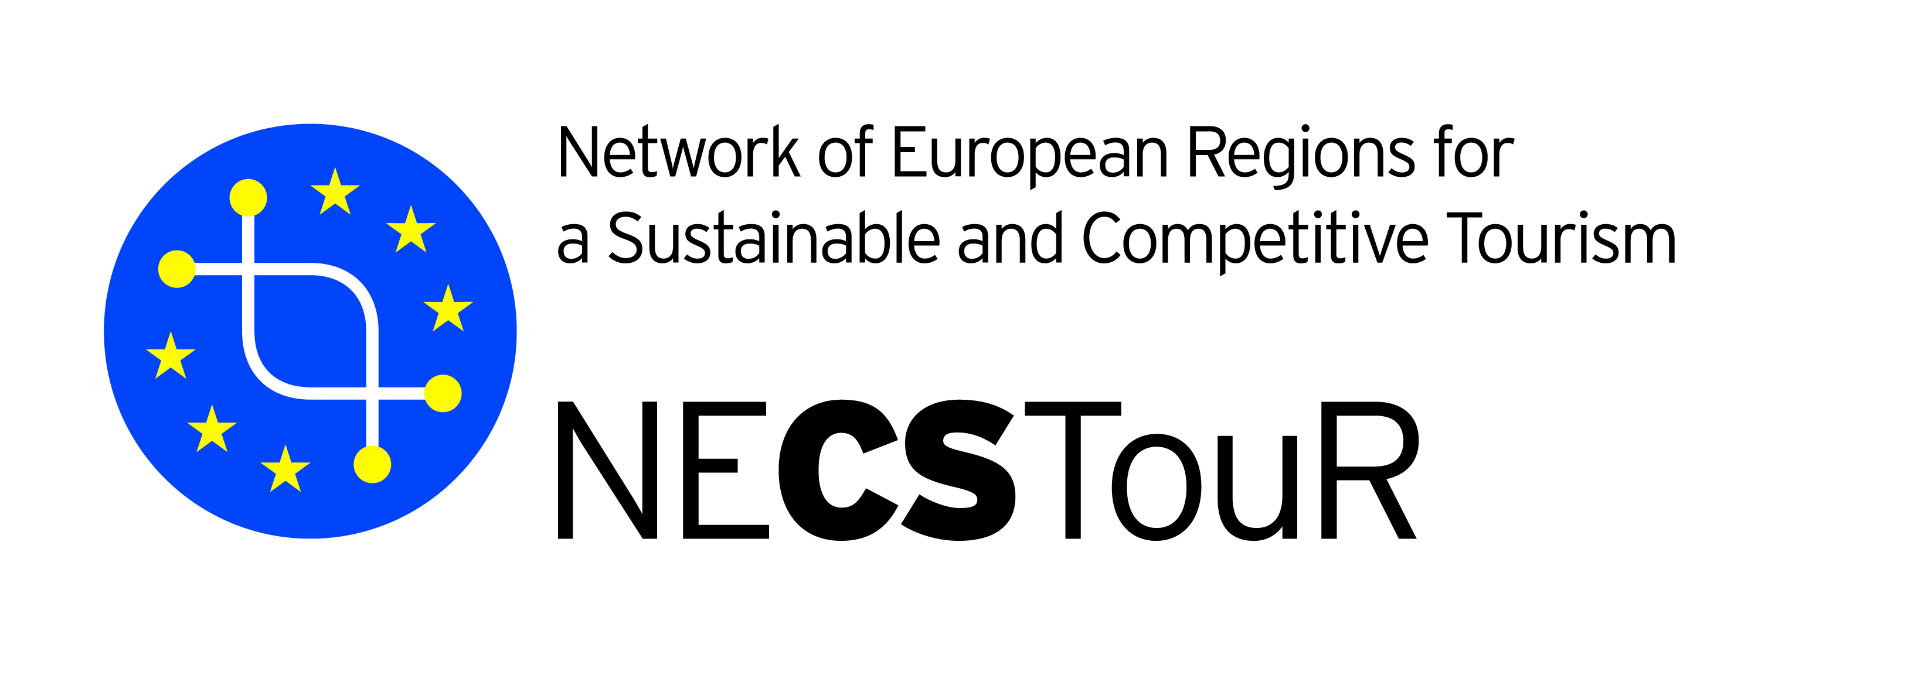
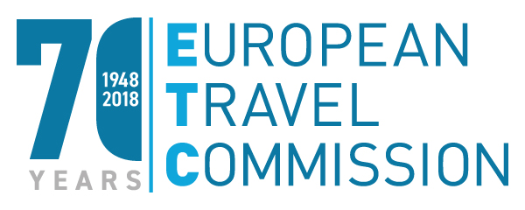
supported by:

Application form

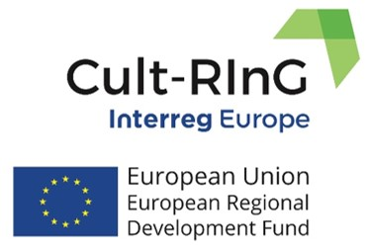
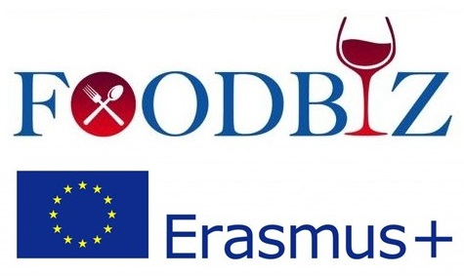
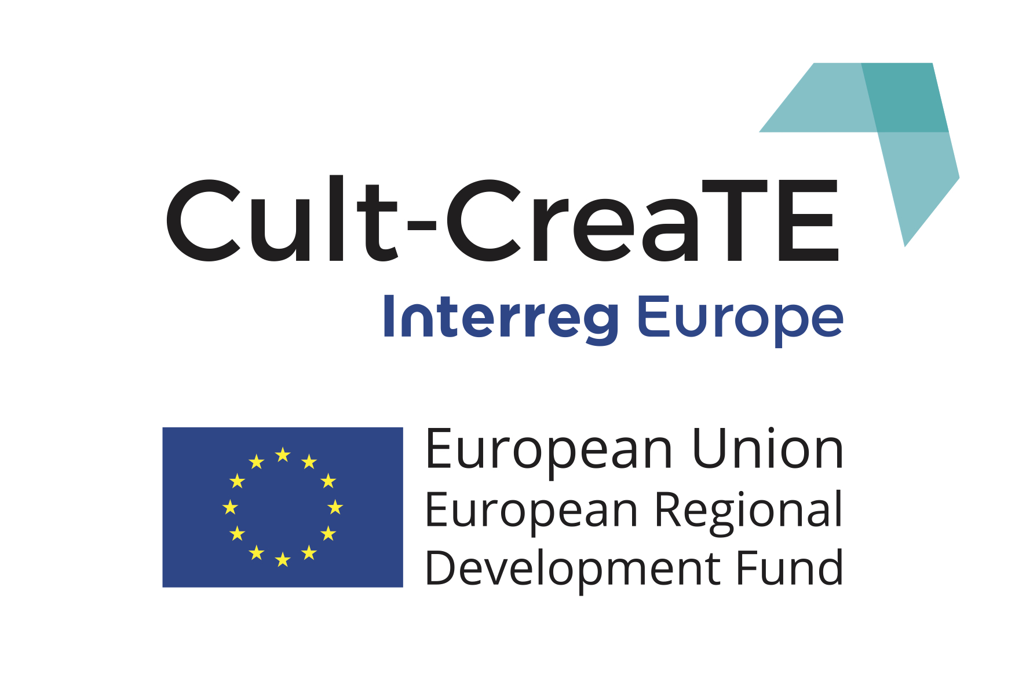
In the frame of EU co-funded projects CHRISTA, Cult-Ring & Cult-CreaTE - Interreg Europe, FOODBIZ - Erasmus+
Application Form

Application Form
This application form should be sent by 1 July 2019 / 17.00 CET (Central European Time)
to: awards@culturaltourism-net.eu

PART 1 Title, Category and Summary

TITLE of the Application (short title of the achievement in one line maximum)

Which heritage-related aspect of cultural tourism is most applicable to your application?
(please, tick only one box)

☐ Intangible Cultural Heritage for Sustainable & Responsible Tourism

☐ Heritage Interpretation for Sustainable Cultural Tourism

☐ Innovation & Digitisation for Sustainable Cultural Tourism

☐ Transnational Thematic Tourism Products, including Cultural Routes

☐ Culinary Heritage, Wine, Food & Gastronomy Tourism

☐ Contributions by Cultural & Creative Industries (CCIs)to Cultural Tourism

☐ Actions during the ‘European Year of Cultural Heritage 2018’, initiative on ‘Tourism & heritage’

SUMMARY of the Application
(describe the achievement in 100 words maximum, this summary will be published)

PART 2 Candidate Information

LOCATION  INFORMATION | The initiative, action, project, strategy etc. (see title provided under part 1) is implemented in:
 | Tourist destination
 | Region
 | Country

CONTACT DETAILS  (of the legal representative of the destination or attraction, action, initiative) | Name  (title, first name, surname)
 | Function
 | Organisation
 | Address
 | Telephone
 | Mobile phone
 | Email
 | Website

PROJECT MANAGER (if not identical to the legal representative) | Name (title, first name, surname)
 | Function
 | Organisation
 | Address
 | Telephone
 | Email
 | Website

PART 3 Statement

This brief statement should cover the aims of the project, action, initiative etc. its achievements and results within the selected heritage-related aspect of cultural tourism, the partners involved, implementation process, budgetary constraints, phases of development, possible findings, events, and the qualities which make it outstanding in a European context 1000 words maximum

PART 4 Supporting materials

This section should include links to: Location Plan (if applicable, preferably to the scale of 1:10 000, on which the site is clearly marked), documentation (regional and state policies, destination, project, initiative etc.), latest report summary, statistical data, and presentations (with information regarding where and to whom this was presented), video online, etc. To complete the dossier, please, reference to this section all supporting materials with valid online links. 1 page maximum

PART 5 Evidence of Success

Photographs
Good quality colour photos (10 maximum) showing clearly the overall situation and important details of the submitted project, initiative, action, etc. with references to sources online. If applicable, photos can include BEFORE and AFTER views, preferably from the same viewpoint, laid out together in the dossier. Wherever possible, please include photos of the work(s) in progress. All photos should be clearly captioned. Please provide links online:

Video and documentaries
Latest video and documentaries (if applicable) in good quality with reference to sources of the submitted projects, actions, initiatives etc. (online, URL) maximum 3 links:

Publications / Articles appeared in media
Links to the articles published in the media between the period 2016-2018 (3 maximum):

Communication
Social media accounts dedicated to the initiative (please provide links):

NB:

Please ensure that any web links are clickable and active, any problematic links cannot be taken into account by the Jury. Do not send any other separate files, they will not be considered by the Jury.

Please submit this form together with the separate signed ‘Declaration’ form.

Check list

Please check that you have completed all sections of the form - the checklist below should help you ensure your application is complete:

Application form

- only one Awards category has been selected
- all fields have been completed
- the application is written in English
- the links provided in the form are active and clickable (see part 5)
- links to max. 10 photos are included (see part 5)
- links to max. 3 videos are included, if applicable (see part 5)
- links to max. 3 publications or articles are included (see part 5)
- the maximum limits have been respected

Declaration

- the separate Declaration form has been filled in, is signed and stamped (scanned version or with digital signature)

Applications that fail to fulfil all requirements will not be considered by the Jury.

Information on the Processing of Personal Data Pursuant to the Regulation (EU) 2016/679 (GDPR)

ECTN informs all applicants for the Awards 2019, pursuant to the Regulation (EU) 2016/679 and the relevant legislation in force with regard to the protection of personal data, in its capacity as organiser, that it processes personal data, collected either with the submission of an application, or at a later time, including data derived from a participants list, or in the framework of external relations, in compliance with GDPR requirements. In particular, where ECTN has requested and received applicants’ consent the processing of data is based on this consent. In such cases applicants have the right to withdraw their consent at any time. However, the processing based on any consent prior to withdrawal remains unaffected.

ECTN takes appropriate technical and organizational measures to ensure the security and confidentiality of applicants’ personal data, their processing and protection from accidental or unlawful destruction, loss, alteration, prohibited transmission, dissemination or access and any other form of unlawful processing.

