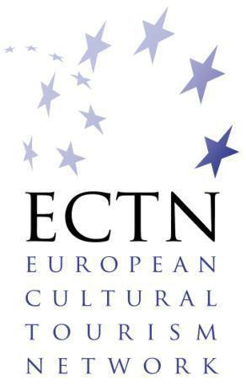
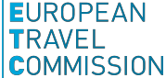
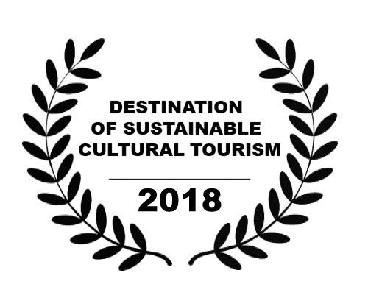
Awards

Awards

Special Edition:
Cultural Heritage as an Asset for Responsible and Sustainable Tourism
in partnership with:

and

as a contribution to:
Application Form

as a contribution to:

Application Form

Application Form

This application form should be sent by 1 July 2018 / 17.00 CET (Central European Time)
to: awards@culturaltourism-net.eu

PART 1 Title and Context

TITLE of the Application (describe the achievement in one line)

Which heritage-related aspect of cultural tourism is most applicable to your application?
(please, tick only one box)

☐ Religious and Pilgrimage

☐ Coastal and Maritime

☐ Cultural Landscapes

☐ Industrial and Military

☐ Historic Houses, Villages and Cities

☐ Transnational Thematic Products

☐ Contribution of Cultural and Creative Industries (CCIs)

PART 2 Candidate

SUMMARY OF INFORMATION | The initiative, action, project, strategy etc. (see title provided under part 1) is implemented in:
 | Tourist destination(s)
 | Region(s)
 | Country(s)

CONTACT DETAILS  (of the legal representative of the destination or attraction, action, initiative) | Name  (title, first name, last name)
 | Function
 | Organisation
 | Address
 | Telephone
 | Mobile phone
 | Email
 | Website

PROJECT MANAGER (if not identical to the legal representative) | Name (title, first name, last name)
 | Function
 | Organisation
 | Address
 | Telephone
 | Email
 | Website

PART 3 Statement

This brief statement should cover the aims of the project, action, initiative etc. its achievements and results within the selected heritage-related aspect of cultural tourism, the partners involved, implementation process, budgetary constraints, phases of development, possible findings, events, approximate total cost, and the qualities which make it outstanding in a European context and particularly in relation to the EYCH 2018 and its objectives (see legal base for a list of objectives).
1 page maximum

PART 4 Supporting materials

This section should include links to: Location Plan (if applicable, preferably to the scale of 1:10 000, on which the site is clearly marked), documentation (regional and state policies, destination, project, initiative etc.), latest report, statistical data, and presentations (with information regarding where and to whom this was presented), video online, etc. To complete the dossier, please, annex or reference to this section all supporting materials with valid online links. 1 page maximum

PART 5 Evidence of Success

Photographs
Good quality colour photos (10 maximum) showing clearly the overall situation and important details of the submitted project, initiative, action, etc. with references to sources online. If applicable, photos can include BEFORE and AFTER views, preferably from the same viewpoint, laid out together in the dossier. Wherever possible, please include photos of the work(s) in progress. All photos should be clearly captioned.
To complete the dossier, please, annex or reference to this section all photos with links online.

Video and documentaries
Latest video and documentaries (if applicable) in good quality with reference to sources of the submitted projects, actions, initiatives etc. (online, URL added).

Publications / Articles appeared in media
Links to the articles published in the media between the period 2015-2017 or scans in pdf (3 maximum) attached.

Communication
Social media accounts (please provide links):

Declaration of entrant

I wish to submit the above-named entry to the Destination of Sustainable Cultural Tourism Award 2018.
I have enclosed the required documentation and agree to the conditions set up by the Awards scheme.

I confirm that I have obtained permission from the owners of the copyright, for ECTN, ETC and Europa Nostra to freely use the photographs and material submitted (and others subsequently requested) for all purposes of communication, publication and promotion of the Awards.

Name Designation

Signature Date

