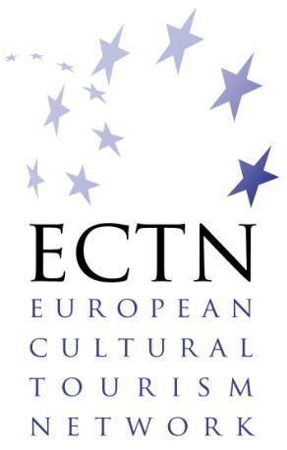
Cultural Tourism –
a Lever for Sustainable Development

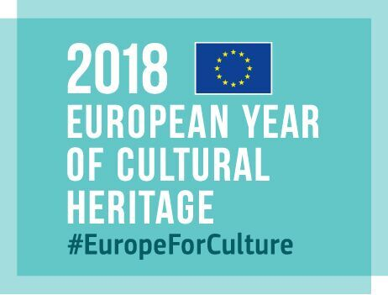
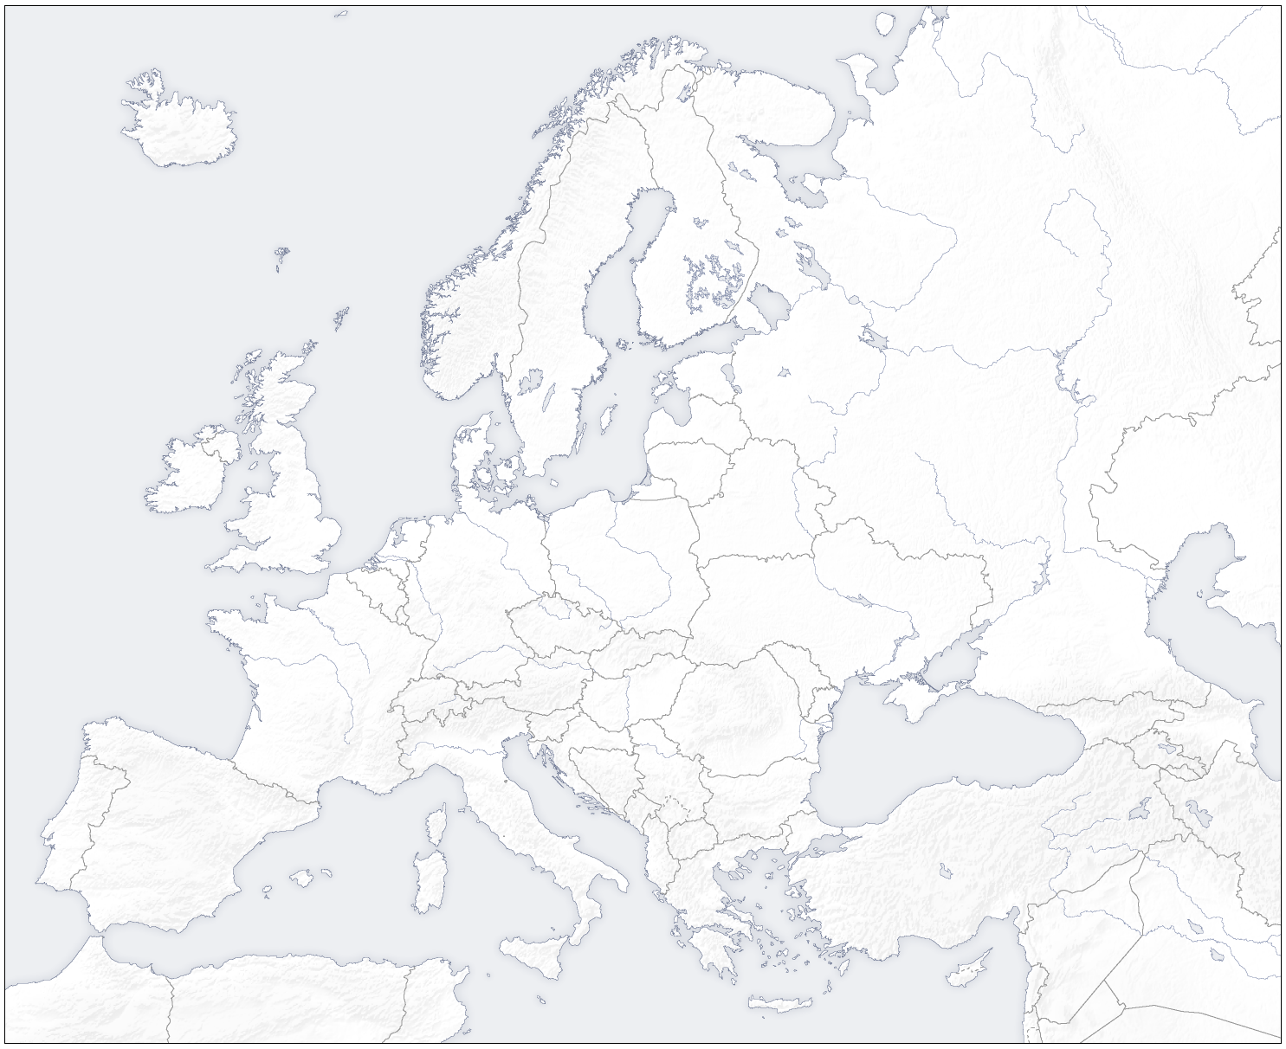

www.culturaltourism-network.eu
Thessalia Charter
for
Sustainable Cultural Tourism

This Charter was first presented and adopted in principle at the closing conference of the CHARTS INTERREG IVC project at Agria, Volos, Magnesia, Thessalia Region, Greece, on 12 September 2014 and hence it became known as the ‘Thessalia Charter’.

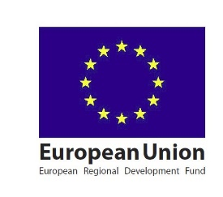
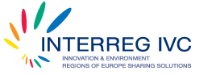
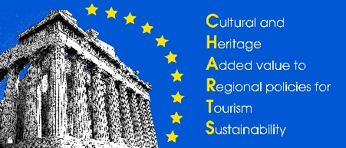

Launched in Brussels for the EU Institutions, Pan-European and International stakeholders on 9 October 2014, during the ‘Open Days - 12th European Week of Regions and Cities’ and in London on 5 November 2014 during WTM World Responsible Tourism Day supported by UNWTO.

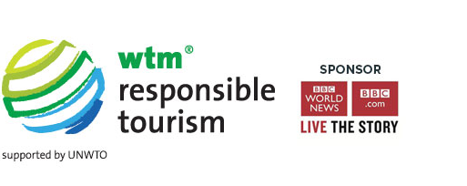

A contribution by ECTN to the ‘European Year of Cultural Heritage 2018’

Third edition, October 2018

Preamble

Purpose of Charter

The purpose of this Charter is to bring together in a single, comprehensive and integrated document the main principles, features, findings, conclusions and recommendations on good practices regarding ‘Culture & Heritage Added-value to Regional policies for Tourism Sustainability’ (CHARTS). This ‘CHARTS Charter’ aims to build on all relevant previous initiatives, declarations, resolutions, opinions and charters, to exploit synergies and facilitate implementation of the recommendations by the national, regional and local destinations authorities responsible. The overall aim is to encourage sustainable and responsible tourism policies and actions across Europe and beyond, through engaging culture and heritage with innovation and cohesion.

This Charter has been developed, discussed and agreed as an output of the CHARTS project in the INTERREG IVC interregional cooperation programme of the European Union, co-funded by the European Regional Development Fund (ERDF). It is aimed at national, regional and local government authorities, destination management agencies, tourism promotion bodies, tourism boards, tourism associations, tourism networks, cultural networks, civil society bodies and community groups, non-governmental organisations, associations of small medium enterprises, European Union institutions, international bodies and other interested bodies and relevant stakeholders.

Mission Statement

The CHARTS Project Mission has been to enrich regional policies with culture and heritage as added value for tourism sustainability by exchange experience amongst the partners in established Good Practices on the sustainable management of culture, heritage and landscape through communication and collaboration, whilst bearing in mind the effects of innovation and creating a base of knowledge that can span well beyond the project’s end. CHARTS Project started in January 2012 and was completed in December 2014.

Structure of Charter

This Charter is structured as follows:

- Principles, where reference to previous relevant documents is made
- Articles, which outline the good practice themes and sub-themes already documented, as well as proposed themes for future capitalisation
- Actions & Proposals, which state the proposed actions and procedures
- Epilogue, on conclusions
- Glossary, giving the definitions of the terms used.

Procedure

This Charter was presented and discussed at the CHARTS Project Closing Conference on 12th September 2014, held in Agria, Volos, Magnesia, Thessalia Region, Greece. This ‘Thessalia Charter’ is adopted in principle by the project partners, with further clarifications and appropriate amendments, enhancements and additions.

The latest version of this ‘Thessalia Charter’ was launched in Brussels for the EU Institutions, Pan-European and international stakeholders on the 9th October 2014, an event within the ‘Open Days - 12th European Week of Regions and Cities’.

The Charter was also launched in London during the ‘World Travel Market’ tourism exhibition on 5th November 2014, as part of the ‘World Responsible Tourism Day’ activities supported by UNWTO, in which the CHARTS Project was an ‘Official Supporter’, with a dedicated stand within the ‘Greek National Tourism Organisation’ space.

A consultation period followed until mid-December 2014, with the final version of the Charter (first edition) published at end December 2014, marking a new era in cultural and heritage sustainable tourism development and promotion in the EU and beyond.

The second edition of the Charter, launched by the European Cultural Tourism Network (ECTN) on 30 November 2016 in Brussels, the day after the European Tourism Day, for consultation with stakeholders, European Union institutions (European Commission DG GROW and DG EAC, European Parliament TRAN & CULT Committees, Committee of the Regions NAT & SEDEC Commissions, EESC), UNWTO / UNESCO, European Travel Commission, Europa Nostra / European Heritage Alliance, local and regional authorities, tourism boards and associations, cultural bodies, research institutes and NGOs.

The third edition of the Charter forms a contribution by ECTN to the ‘European Year of Cultural Heritage 2018’ and in particular to the 5th initiative on ‘Tourism & heritage: responsible and sustainable tourism around cultural heritage’.

Principles

This Charter is a statement of principles on regional policies and strategies which guide the development, planning, management, operations and promotion of cultural and heritage tourism in the European Union and beyond, for the benefit of destinations, communities, businesses, citizens and visitors.

Having regard to:

- The International Cultural Tourism Charter ‘Managing Tourism at Places of Heritage Significance’ (1999) by the International Council on Monuments and Sites (ICOMOS), which appreciates tourism to be among the foremost vehicles for cultural exchange, constituting a positive force for natural and cultural conservation.
- The Cape Town Declaration on ‘Responsible Tourism in Destinations’ (2002), at an event preceding the World Summit on Sustainable Development, which agreed that responsible tourism:

- minimises negative economic, environmental and social impacts
- generates greater economic benefits for local people and enhances the well being of host communities; improves working conditions and access to the industry
- involves local people in decisions that affect their lives and life chances
- makes positive contributions to the conservation of natural and cultural heritage embracing diversity
- provides more enjoyable experiences for tourists through more meaningful connections with local people, and a greater understanding of local cultural, social and environmental issues
- provides access for physically challenged people
- is culturally sensitive, encourages respect between tourists and hosts, and builds local pride and confidence.

- The Riga Charter on ‘Railway Heritage’, adopted by FEDECRAIL, the European Federation of Museum and Tourist Railways in April 2005 (having been first proposed in Riga, capital of Latvia in 2002), to guide decisions that will result in heritage railways being able to be enjoyed by future generations, being a statement of principles which guide the conservation, restoration, maintenance, repair and use of historic railway equipment, which is being operated.

- The Cardiff Declaration of European Cultural Tourism Network (ECTN) INTERREG IIIC project (July 2005), which points out that cultural tourism can help further European integration and recommends ways for promoting cooperation in respect of cultural tourism.
- The Malta Declaration on ‘Cultural Tourism: its Encouragement and Control’, by the Europa Nostra Congress (May 2006), which recognizes cultural heritage as a distinct feature of the European Identity that should be safeguarded.
- The Gothenburg Declaration of the European Cultural Tourism Network (ECTN) INTERREG IIIC project on ‘the creative future – cultural tourism as a sustainable and growing sector’ (November 2006), which focuses on the need to actively involve the community in the development and management of Cultural Tourism.

- The Davos Declaration on Climate Change and Tourism – Responding to Global Challenges by UNWTO, jointly with the United Nations Environment Programme (UNEP) and the World Meteorological Organization (WMO), with the support of the World Economic Forum (WEF) and the Swiss Government, in 2007, which recognizes that:
- Climate is a key resource for tourism and the sector is highly sensitive to the impacts of climate change and global warming
- Tourism will continue to be a vital component of the global economy, an important contributor to the Millennium Development Goals and an integral, positive element in our society
- The tourism sector must rapidly respond to climate change and progressively reduce its Greenhouse Gas (GHG) contribution, with action to mitigate its GHG emissions; adapt tourism businesses and destinations to changing climate conditions; apply existing and new technology to improve energy efficiency; secure financial resources to help poor regions and countries.

- The Declaration of the Council of Museums (ICOM) and the World Federation of Friends of Museums (WFFM) for worldwide Sustainable Cultural Tourism (December 2007), which concludes that “changes in attitudes and greater understanding lead to new, holistic ways of preserving ecosystems in tourist destinations, and contribute to protecting the cultural uniqueness of the visited communities as a whole (and not just of that segment of the population directly involved in tourism). ICOM and WFFM firmly believe that museums and friends of museums can make a significant educational, cultural and political contribution to the sustainable development of tourism”.

- The Magnesia Declaration on ‘Cultural Heritage and Tourism Development' by CHIRON INTERREG IIIB CADSES project, signed in Agria, Magnesia, Greece (July 2008), which calls upon local communities to be fully involved in conserving cultural heritage sites and emphasizes the need for partnerships at all levels in order to maximize the benefits of the tourism sector.

- The ‘Cittadella Declaration’ on sustainable and innovative tourism development, by CHARTS INTERREG IVC Consultative Board meeting held at Villa Contarini, Cidadella, Veneto Region, Italy, in May 2013, which proposes a new tourism approach, with the tourists at the centre of all actions, active and passive, that:
  - Promotes “niche” and less known destinations
  - Collaborates with smaller cities and less developed tourist destinations
  - Prolongs the tourist season flows, diversifying the touristic flow covering all seasons
  - Promotes tourist destination located in the whole regional territory
  - Improves different and innovative types of tourism (i.e. cycling for tourists, tourism by boats, eco-friendly means of transportation, slow food, traditional skills and the local products and gastronomy, etc)
  - Is sustainable, from the economic (improving its revenue generating all to the good of the local economy), social and environmental points of view.

- The ‘Siem Reap Declaration on Tourism and Culture – Building a New Partnership Model’ by UNWTO and UNESCO in Siem Reap, Cambodia, February 2015, (at the World Conference on Tourism and Culture, which brought together for the first time Ministers of Tourism and Culture as well as key stakeholders from around the world), that reaffirmed their commitment to build new partnership models between tourism and culture, promote and protect cultural heritage, link people and foster sustainable development through cultural routes, promote closer linkages between tourism, living cultures and creative industries and promote the contribution of cultural tourism to urban development, in advancing the links between tourism and culture in the aim of promoting a more sustainable future for all.

- The ‘Tourism Manifesto for Growth and Jobs’ launched in December 2015, led by the European Travel Commission, with ECTN been an active signatory since May 2016, which includes 'preservation of cultural heritage' on the cover page, in terms of tourism benefits and stronger awareness of European citizenship, as well as explicit references to thematic tourism including culture, gastronomy and cycle routes, quality schemes including heritage, digitalisation, diversification, visitor economy, climate and job creation goals, local communities, visitor's experience, multi-modal mobility, connectivity, accessibility, holistic European approach, EU funding and integrated approach to the travel and tourism sector.

And to the following key Communications, Opinions, Resolutions, Decisions and Conclusions of European Union Institutions, UNESCO and UNWTO:

- Communication COM(2010) 352 final: Europe, the world’s No 1 tourism destination – a new political framework for tourism in Europe.
- Communication COM(2014) 85 final: Proposal for a Council Recommendation on European Tourism Quality Principles.
- Communication COM(2014) 477 final: Towards an integrated approach to cultural heritage for Europe, which recognizes the heritage spill-over effect in tourism and that heritage can help brand cities and regions attracting talent and tourism; that wise heritage management can be successful and sustainable through the promotion of cultural tourism; that promoting tourism around European cultural & industrial heritage contributes towards sustainable, responsible and high-quality tourism, including the Council of Europe cultural routes programme and underwater cultural heritage.
- Responses and Resolutions of the European Parliament, the Committee of the Regions and the European Economic & Social Committee, regarding the above.
- The Conclusions of the annual European Tourism Forum, organized by the Presidency of the Council of Ministers and the European Commission since 2002, as far as they concern sustainable, responsible and cultural tourism.
- The Conclusions of the Council of the European Union on cultural heritage as a strategic resource for a sustainable Europe (2014), according to which cultural heritage has a significant economic impact while it plays an important role in creating and enhancing social capital.
- The UNESCO World Heritage and Sustainable Tourism Programme (WH+ST), Action Plan 2013-2015, for the implementation of the World Heritage Convention through international cooperation across sectors from strategic planning to destination management, for sustainable tourism and economic development; focusing on partnerships between the public, private and voluntary sectors for effective planning, action and impact on World Heritage conservation.
- The UNWTO Executive Council thematic discussion (99th session, October 2014), witch stressed the need to promote new governance models to foster closer cooperation between tourism and culture in order to advance the sustainable development of cultural tourism, as well as other issues on tourism and culture including congestion management, financing, public-private sector cooperation, the role of local communities in tourism development and cultural preservation, the promotion of events, creative industries and contemporary culture and history in enriching the visitor experience.
- The document ‘Cultural Heritage Counts for Europe’ (CHCfE), published on behalf of the CHCfE Consortium (comprising Europa Nostra, ENCATC, Heritage Europe, ICC, RLICC and the Heritage Alliance UK), by the International Cultural Centre, Krakow, in June 2015; this document co-funded by the Culture Programme of the EU with a foreword by Europa Nostra President maestro Placido Domingo, has four out of ten key findings explicitly related to cultural tourism, such as cultural heritage providing a unique identity, basis for effective marketing strategies aimed at developing cultural tourism and attracting investment, job creation through cultural tourism, creativity and innovation in heritage interpretation for visitors, quality of life and attractiveness for tourists.
- The European Parliament resolution ‘Towards an integrated approach to cultural heritage for Europe’ (of 8 September 2015), which recognizes that heritage resources create value and contribute to economic growth through cultural tourism, EU funding for cultural heritage and tourism is available but fragmented and that the cultural and touristic value of the Council of Europe’s Cultural Routes in developing sustainable cultural tourism should be strengthened; an integrated approach in put forward including new governance models involving cultural and creative industries, tourism operators, PPPs and NGOs, the economic and strategic potential of cultural heritage through stressing the importance for European tourism of UNESCO-designated tangible or intangible cultural heritage and natural heritage, support for ‘soft travel’ (walking, horse-riding and cycling tours) as cultural and nature-based tourism, pointing out that cultural tourism accounts for 40% of European tourism, urges the Commission to promote joint cultural heritage and tourism programmes to serve as a benchmark of best practice, points out that cultural heritage and tourism are mutually beneficial since tourism is good for culture, stresses that cultural tourism plays a major role in preserving our cultural heritage including intangible heritage such as languages, religious and culinary traditions, and finally supporting the creation of transnational cultural tourism products which reflect common European values and heritage and calls for greater cooperation with UNWTO and UNESCO and to continue to co-finance and promote networks, cross-border regional projects in cooperation with CoE CRs as best example of transnational pan-European thematic tourism projects.
- The United Nations General Assembly 70th session 2nd Committee Agenda item 20 - Sustainable development, decision on ‘International Year of Sustainable Tourism for Development 2017’ (18 November 2015), which proclaims 2017 as the IYSTD, invites the UNWTO to facilitate the organisation and implementation in collaboration with Governments, relevant organisations of the UN system and other stakeholders, encouraging all States, the UN system and all other actors to promote actions, including through international cooperation, and to support sustainable tourism as a means of accelerating sustainable development; with ‘Cultural values, diversity and heritage’ and ‘Inclusive and sustainable economic growth’ being two of five key areas that the International Year 2017 shall explore and highlight tourism’s role.
- The Committee of the Regions Opinion NAT-VI/009 on ‘Tourism as a driving force for regional cooperation across the EU’, to be adopted at the 120th plenary session on 7 December 2016, which inter-alia: supports the call to introduce a budget heading for promoting European tourism into the annual EU budget to finance innovative cross-border projects, and also supports more consideration of investments with relevance to tourism in post-2020 EU regional policy; proposes the promotion of thematic tourism projects in the sense of smart specialisation (smart regions/cities) so as to counteract mass tourism, and also suggests introducing the title of "European Capital of Smart Tourism", to be awarded to up to three EU cities/regions per year by representatives of the tourism industry, the EC, the EP and the CoR; calls for cultural, historical and religious tourism to be supported, which contributes to employment, multicultural understanding and local, regional and rural development, and calls for tourist attractions to be linked so as to create European, national and local thematic trails; calls on the regions to consider sustainability in their tourism strategies; supports development of sustainable cultural tourism in cities which can be a vital catalyst for revenue generation for innovative practices in heritage conservation and management; proposes a media prize ("tourism Oscar"), awarded by the EC, EP and CoR, to recognise (print and audio-visual) documentation that transmits knowledge about the European cultural and natural heritage, as well as about regional and local tourist attractions in Europe, and contributes to a sense of European citizenship.
- Communication COM(2016) 543 final on ‘Proposal for a Decision of the European Parliament and of the Council on a European Year of Cultural Heritage’ 2018 (EYCH 2018), 30 August 2016, approved by the Council of Ministers on 22 November 2016, with the following objective for EYCH 2018 inter-alia: “It should enhance the contribution of European cultural heritage to the economy and society, through its direct and indirect economic potential. This includes the capacity to underpin the cultural and creative industries and inspire creation and innovation, promote sustainable tourism, and generate long-term local employment”.

Whereas:

- Cultural and heritage tourism is the fastest growing sector of European tourism and can contribute to the sustainability and competitiveness of tourism in the European Union and its neighbouring countries
- Europe has the richest cultural heritage and identity in the world which enriches visitors and contributes to inter-cultural dialogue and understanding, including between EU member states, candidate and neighbouring countries
- The tourism sector can facilitate the conservation of cultural heritage, a process that requires responsibility, integrity, cooperation and commitment by all concerned
- Local communities should be fully involved in conserving cultural heritage sites and in the promotion of sustainable tourism
- The development of tourist destinations is linked to their cultural distinctiveness
- Creating the right balance between the needs of the cultural environment and the development of competitiveness of destinations requires an integrated approach where all shareholders share the same objectives
- Sustainable tourism is crucial for the preservation and enhancement of Europe’s cultural heritage
- Concrete benefits to the tourism sector may be achieved by facilitating partnerships at all levels and with all actors, including transnational partnerships
- The creation of innovative and transnational new tourism products based on culture and heritage plays an important role in increasing tourism participation
- There is a need to plan towards sustainable development of tourism and in particular the development of cultural and heritage tourism
- Emphasizing that the Common European Identity is the strongest bond of the European Union, while the multidimensionality of the European Cultural Heritage is the key element of the unique wealth of the European Culture
- Recognizing that Cultural Heritage is a unique, irreplaceable and non-interchangeable resource which is inherited from the previous generations and passed on to the next, which is constituted of all cultural assets including monuments, sites, landscapes, skills and various expressions of knowledge and creativity.

It is agreed to adopt all of the above previous documents and principles therefrom.

It is agreed furthermore to follow, adopt, apply and promote the following good practice themes inter-alia, for implementation during the period 2014-2020 and beyond, building on the transfers of these good practices between partner regions within the CHARTS project and their Implementation Plans addressed inter-alia to their respective Managing Authorities.

Articles

This Charter calls for the following good practices themes to be adopted, followed, applied, promoted, enhanced and implemented in destinations towards tourism sustainability:

- Climate Change

- Cultural tourism destinations and climate change impacts Risk Assessment
- Adaptation and mitigation measures and priorities
- Protection of cultural assets from related risks and setting up monitoring measures
- ‘Greening’ of visitor experience
- Reducing greenhouse gas emissions by sustainable travel choices for tourism as well as sustainable mobility solutions at destinations

- Accessibility to Heritage

- Improving intellectual and physical accessibility to the heritage
- Accessibility for persons with disabilities and disadvantaged social groups, Accessible Tourism
- Interpretation and signing of cultural assets
- Promotion of all means of access to heritage, including virtual, perceptual and tangible
- Making the heritage environment, products and communication more available and accessible for all, at lowest cost

- Effective Partnerships

- Building effective partnerships at the destination level between cultural and tourism sectors﻿, as well as between local government authorities
- Improving the offer and developing innovative pilot projects that encourage visitors to stay longer and engage with local culture and heritage
- Involving all stakeholders from the public, private and voluntary sectors and all tourism-related providers for sustainable tourism development
- Interregional and transnational cooperation and networking

- Host Communities & Responsible Tourism

- Engaging with host communities of tourism destinations
- Fostering civic pride, awareness and welcoming
- Developing a resource within the community
- Maximising local benefits and minimising negative impacts
- Ensuring mutual respect between tourists and residents
- European Capital of Culture experiences, impacts, plans and operations
- Promoting commitment to ‘Responsible Tourism’, with ethical concerns, equality, long-term vision, certification and award schemes
﻿

- Quality Criteria

- Development of quality criteria for cultural and heritage tourism destinations to measure performance in terms of tourism sustainability
- Contributing to ‘European Tourism Quality Label’ initiative of European Commission
- Support and apply the European Tourism Indicator System (ETIS) for Sustainable Destination Management
- Pilot implementation of ‘European Heritage Label’ proposals
- Creation of ‘emotional maps’, a mapping of the visitors ‘journey’ through a destination from the planning of the visit to its end and the recording of emotions and emotive experiences during the different stages (experience based co-design quality assessment method)
- Links of cultural and natural heritage to ‘Quality Coast’ designation

- Visitor Information

- Enhanced information for Visitors through Information Centres & Info Kiosks
- ICT applications, Video documentaries, Multimedia production
- New Media Tools, Virtual Reality, Animation, Creativity
- Innovations through Social Media, Networking and Web Applications
- Information on conserving natural and cultural heritage and diversity

- Place Marketing

- Place Marketing Innovative Strategies based on cultural heritage, local distinctiveness and regional identity
- Branding procedures with culture and heritage synergies
- Marketing actions for all year round sustainable and cultural tourism development
- Tourism promotion, exhibitions, events and road shows

- Cultural Routes

- Cultural Routes – according to the Council of Europe and the European Institute of Cultural Routes
- Preparatory actions for creation, designation and certification
- Development and promotional strategies of Cultural Routes
- Impacts on inter-cultural dialogue, creativity, innovation and competitiveness
- Contribution to initiatives for supporting innovative and transnational tourism products

- Railway Heritage

- Railway Heritage Preservation and Promotion for Cultural and Industrial Tourism
- Promoting Industrial Heritage of Steam Railways
- Twinning arrangements between legendary heritage railways and joint marketing
- Promotion of ‘Riga Charter’ for conservation, restoration, maintenance and repair of historic railway equipment

- Local Products & Gastronomy

- Promotion of local products with denomination of origin certification
- Increasing awareness about local cuisine and traditional recipes
- Healthy diet for visitors and creative cuisine
- Local identity enhancement through eno-gastronomy and culinary practices intangible heritage

- Traditional Skills & Trades

- Preservation of traditional skills and trades that are becoming extinct (such as: maritime professions, horse shoe maker, saddle maker, ironsmith, masonry crafts)
- Promotion of the traditional skills and trades procedures as events for visitors and tourist attractions
- Intangible cultural heritage of handicrafts and traditional craftsmanship

- Cycling for Tourists

- Promotion of cycling in cultural tourism destinations for sustainable mobility
- Communal, shared bike schemes for tourists and visitors
- Cycle trails as cultural tourism attractions
- Cycling tourism as sustainable, environmentally friendly tourism
- Combination of cycling with other sustainable means of tourism and leisure mobility.

The above themes have been included in the CHARTS INTERREG IVC project and the outputs are in the form of ‘Web based toolkits’ on the specific good practice topics for cultural tourism destinations, comprising a ‘Good Practice Guide’, an overall presentation supporting the Guide, a Leaflet summarising the key findings and a Video clip highlighting the Good Practice theme, procedures and results.

Further work is required through interregional cooperation in the future on the following additional themes, inter-alia:

- Intangible Heritage for Sustainable & Responsible Tourism

- Industrial Heritage Tourism

- Heritage Interpretation Facilities

- Digitalization & Innovation in Cultural & Sustainable Tourism

- Sustainable Mobility, Accessibility and Responsible Travel, within Destinations and for Access to/Connectivity of Destinations

- Cultural & Creative Industries and Synergies with Sustainable Tourism

- Mobilizing Volunteers in Cultural & Heritage Tourism

- Religious & Pilgrimage Tourism

- Experience Economy Synergies with Cultural Tourism

- Maritime, Coastal & Aquatic Heritage for Tourism

- Creative Tourism

- Education & Training for Cultural & Heritage Tourism

- Age – friendly Tourism, Silver Tourism

- Youth Incentives for Cultural Tourism through Heritage

- Wine Tourism

- Conservation and its contribution to Cultural Tourism

- Sharing Economy impacts on Tourism

- Enhanced Governance for Cultural Tourism, including Funding

Actions and Proposals
On the basis of the above, this Charter proposes the following actions:

- To strengthen the procedures and instruments for cultural tourism development and promotion, particularly in the form of implementation plans for the transfer and adoption of good practices and through effective destination management
- To involve all key stakeholders in close cooperation between cultural and tourism sectors, including public, private and voluntary sectors, as effective partnerships
- To strengthen the information means, channels and materials for the promotion, education, study and awareness-raising of visitors before, during and after their visits, including creation of multilingual promotion materials
- To create place marketing frameworks, strategies, plans and channels for cultural tourism in all forms
- To strengthen the sustainability and competitiveness of European tourism through cultural routes and cultural landscapes
- To encourage and facilitate the networking of cultural tourism destinations, also including policy makers, practitioners and researchers.

The European Cultural Tourism Network strongly calls upon Destinations and stakeholders:

- To endorse this Charter and to adopt its principles and articles
- To establish an overall informal and enlarged European Network of Cultural & Heritage Sustainable Tourism destinations that will endorse, adopt, apply, update, enhance and further disseminate this Charter
- To work together towards the development and promotion of Cultural & Heritage Tourism, in accordance with relevant documents, instruments and initiatives of the European Union institutions and UNWTO/UNESCO
- To raise awareness about engaging Culture and Heritage for Sustainable Tourism Development, towards enhancing social and economic cohesion, sustainability and competitiveness of European tourism.

Furthermore, the European Cultural Tourism Network strongly calls upon the relevant European Union Institutions (European Parliament, Committee of the Regions, European Commission, European Economic & Social Committee):

- To assist, fund, facilitate and support schemes, initiatives and pilot actions in the field of cultural and heritage tourism development and promotion
- To support the work of pan-European Networks for the development and promotion of sustainable, cultural and heritage tourism
- To promote the advantages of cultural and heritage tourism in relation to sustainable development, the environment, climate change mitigation and adaptation, employment creation, cohesion and competitiveness
- To facilitate the co-funding of actions and services for Quality, Cultural and Heritage Tourism, on the basis of the expected sustainability, cohesion, regional development and competitiveness benefits.

Towards the above goals, the European Cultural Tourism Network and the ‘Thessalia Charter’ signatories hereby propose to establish an overall, informal and enlarged umbrella ‘Network of European Cultural and heritage Tourism Authorities and Research institutes’ (NECTAR), on a voluntary basis, including the European Cultural Tourism Network (ECTN), the CHIRON project network, and other relevant networks and bodies active in this and closely related fields, as a platform for endorsing and promoting the ‘Thessalia Charter’ principles and practices.

We encourage other local and regional authorities, destination management agencies, cultural associations, tourism promotion agencies, tourism boards, other relevant networks, SME associations and NGOs throughout Europe to adopt this Charter and to join us in the establishment of the enlarged informal Network through NECTAR, working together in ‘engaging culture and heritage for sustainable tourism development’.

Actions and Proposals

Epilogue

This Charter reflects the increasing emphasis given to the issues concerning the preservation and diffusion of the European Culture and Heritage (including contemporary culture and natural heritage), in the light of its connection to Responsible Tourism and Sustainability. In this context, the creation of sustainable, innovative and transnational new and upgraded tourism products and services based on culture and heritage should be considered of crucial importance. The emphasis of the Charter is on tackling climate change impacts at destinations, provision of access for all to the cultural and natural resources, building effective partnerships at the destination level, involvement of the local host communities, familiarization of visitors with the local culture and heritage towards responsible tourism, enhancing services quality and visitor information, introducing place marketing strategies, promoting cultural routes, railway heritage, gastronomy, traditional skills, cyclo-tourism, as well as overcoming the economic crisis and its aftermath through employment generation, innovation, socio-economic cohesion and sustainable development.

First edition presented at Agria, Volos, Magnesia, Thessalia Region, Greece
on 12 September 2014 and launched in Brussels on 9 October 2014.

Second edition launched in Brussels on 30 November 2016.

Third edition launched in October 2018, following consultation, as a contribution to ‘European Year of Cultural Heritage 2018’.

the only pan-European network
for cultural tourism development and promotion
Contact:
info@culturaltourism-net.eu

brings together
the tourism and cultural industry professionals
working in different regions of Europe
to exchange experience and
information on best practice and
to develop new approaches and innovations

www.culturaltourism-network.eu

